# AI ASSISSTED CODING -15.3

NAME : S.NADHIYA

ROLL NO : 2403A510C6

BATCH : 05

DEPT : CSE

**Task - 01**

**Prompt:**

Generate a simple HTML homepage for a 'Student Info Portal' with a header, navigation menu, main content, and footer — use clean indentation, comments, and basic CSS styling.

**Code:**

**Flask_api.py**

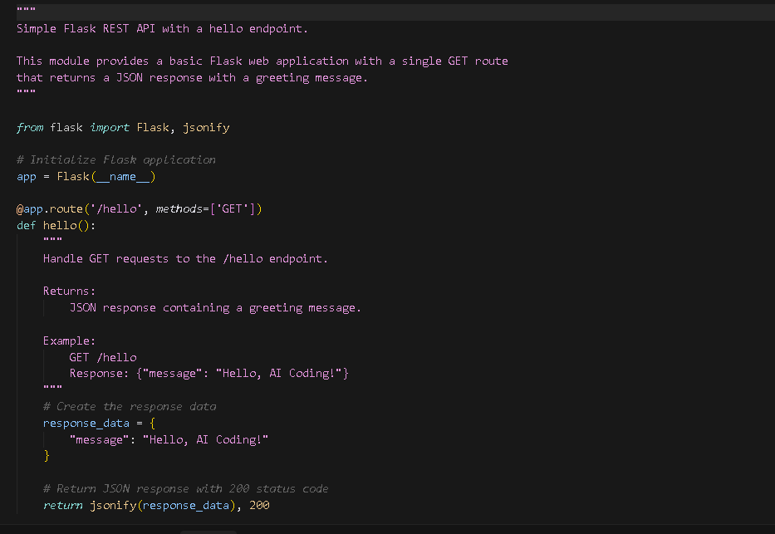

**Requirement.txt**

**Output:**

**Observation:**